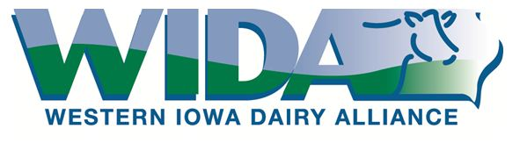
Working Together.
Taking a Stand.
Partnering for Progress.

2020 Industry Partner
Membership Application

Company Name | «Company»
Name of Primary WIDA Contact  Title | «Name»
Street Address  City, State, Zip Code | «Address»  «City»«State»«Zip_Code»
Email Address

Phone
Company Website

List additional employees or contacts who should receive WIDA mailings or email newsletters on the back side.

Please select membership level

Bronze | $500 | - Company name and link to web site on www.wiadairy.com  - Company name listed in Year in Review report mailed to WIDA membership
Silver | $1000 | - Company name, logo and link to website on www.wiadairy.com  - Company logo on monthly WIDA email newsletters  - Company name and logo listed in Year in Review mailed to WIDA membership  - Article in one WIDA email newsletter OR display opportunity at the annual meeting  - One mailing or email sent to WIDA members on their behalf in a membership year
Gold | $2500 | - Company name, logo and link to website on www.wiadairy.com  - Company logo on monthly WIDA email newsletters  - Company name and logo listed in Year in Review mailed to WIDA membership  - Article in one issue of WIDA email newsletter (can be company profile, customer case study, or educational article)  - Display opportunity at the annual meeting  - Gold Membership includes sponsorship of WIDA open house, and educational events during 2018  - Two mailings or emails sent to WIDA members on their behalf in a membership year

Mail renewal form and check to:
Western Iowa Dairy Alliance
400 Central Ave. NW # 900
Orange City, Iowa 51041

Contact Scott Schroeder at 712-441-5308 or info@wiadairy.com for questions or if an invoice is needed.

